CONFIDENTIAL CS/OCT 2026/MAT133

UNIVERSITI TEKNOLOGI MARA FINAL EXAMINATION

COURSE
COURSE CODE
EXAMINATION TIME
PRE CALCULUS
MAT133 OCTOBER 2026
2 HOURS

INSTRUCTIONS TO CANDIDATES

- This question paper consists of 5 questions.

- Answer ALL questions in the Answer Booklet. Start each answer on a new page.

- Do not bring any material into the examination room unless permission is given by the invigilator .
- Please check to make sure that this examination pack consists of: i) the Question Paper
  - a one - page Append ix 1
  - an Answer Booklet - provided by the Faculty
  - a graph paper - provided by the Faculty

- Answer ALL questions in English.

/

DO NOT TURN THIS PAGE UNTIL YOU ARE TOLD TO DO SO

This examination paper consists of 7 printed pages

QUESTION 1
a) Solve the inequality 5x + 3 < -1. Express the answer in interval notation.
(4 marks)
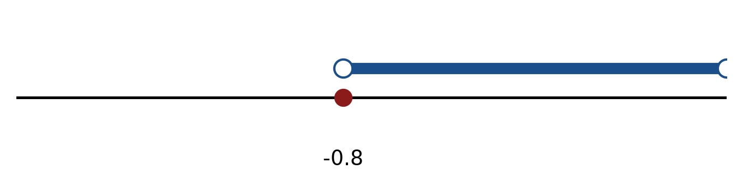
Figure: solution on a number line.
b) Solve the inequality |2x + 2| < 2. Express the answer in interval notation and on a number line.
(5 marks)
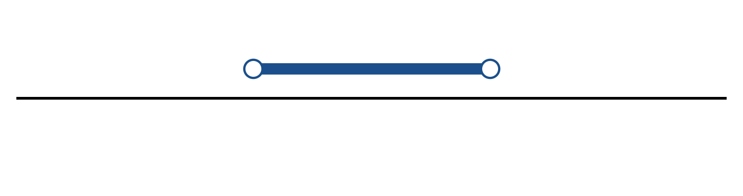
Figure: solution on a number line.
c) Sketch y = 2|x - 4| - 1. State the vertex, the y-intercept and any x-intercepts.
(5 marks)
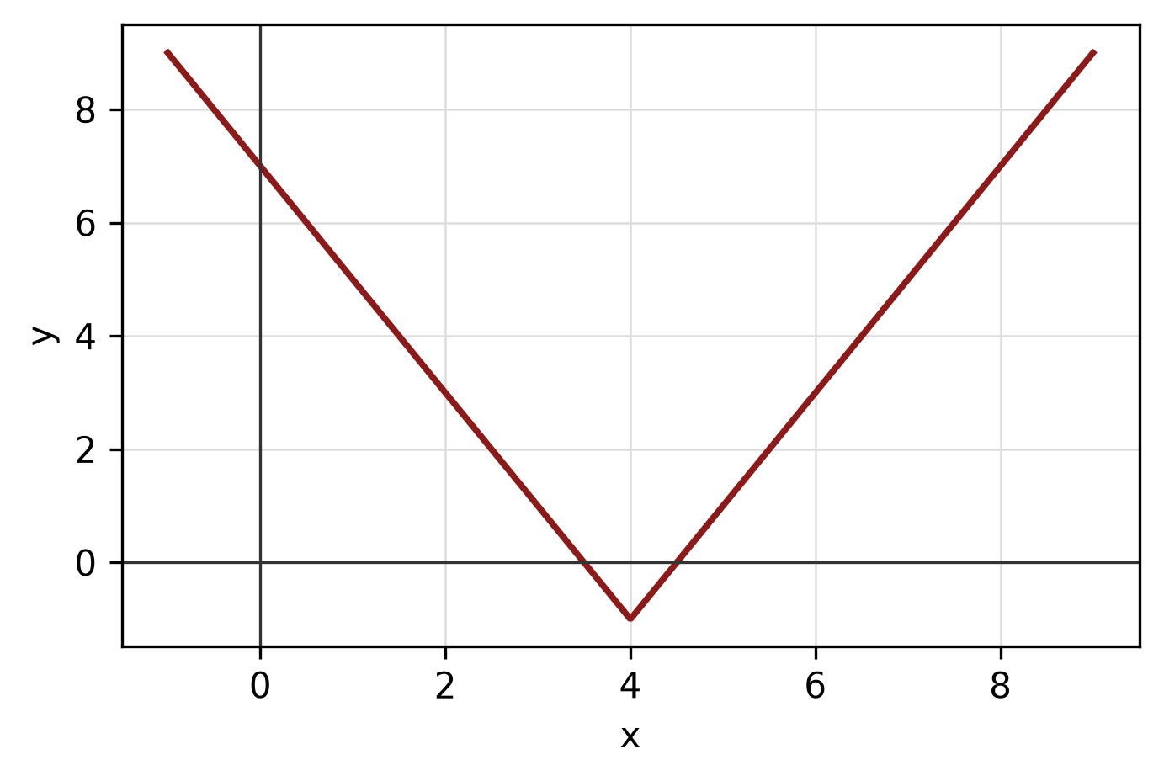
Figure: absolute-value graph.
QUESTION 2
a) Determine algebraically whether f(x) = x^5 - 2x^3 - 5x is even, odd or neither. State the symmetry of its graph.
(4 marks)
b) Apply graph-transformation techniques to sketch y = -(x - 2)² + 5. State the vertex and the y-intercept.
(5 marks)
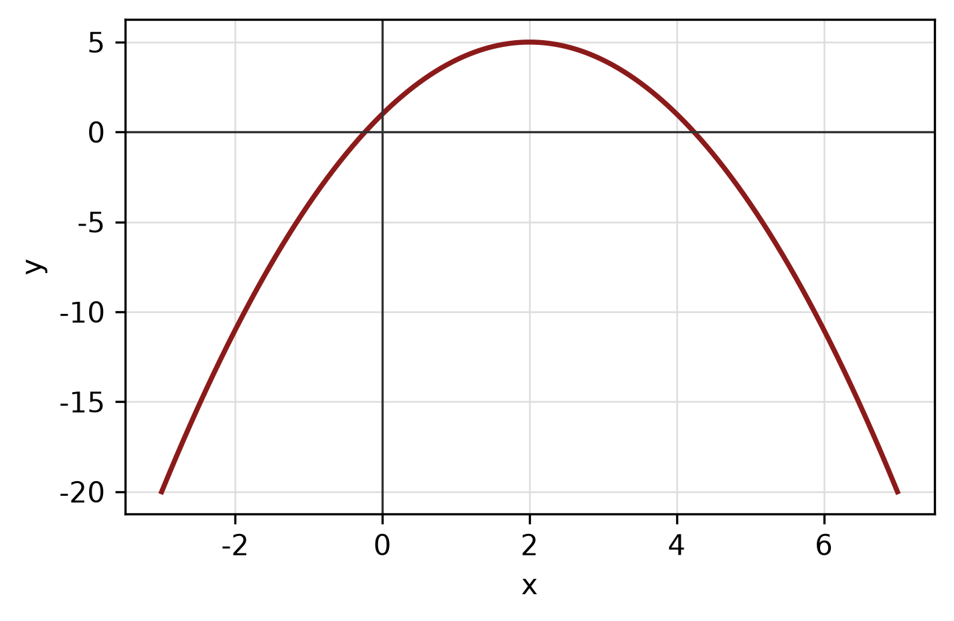
Figure: transformed graph.
c) Write the equation of the circle with centre (5, -4) and radius 7. Hence write its general equation and sketch the circle.
(5 marks)
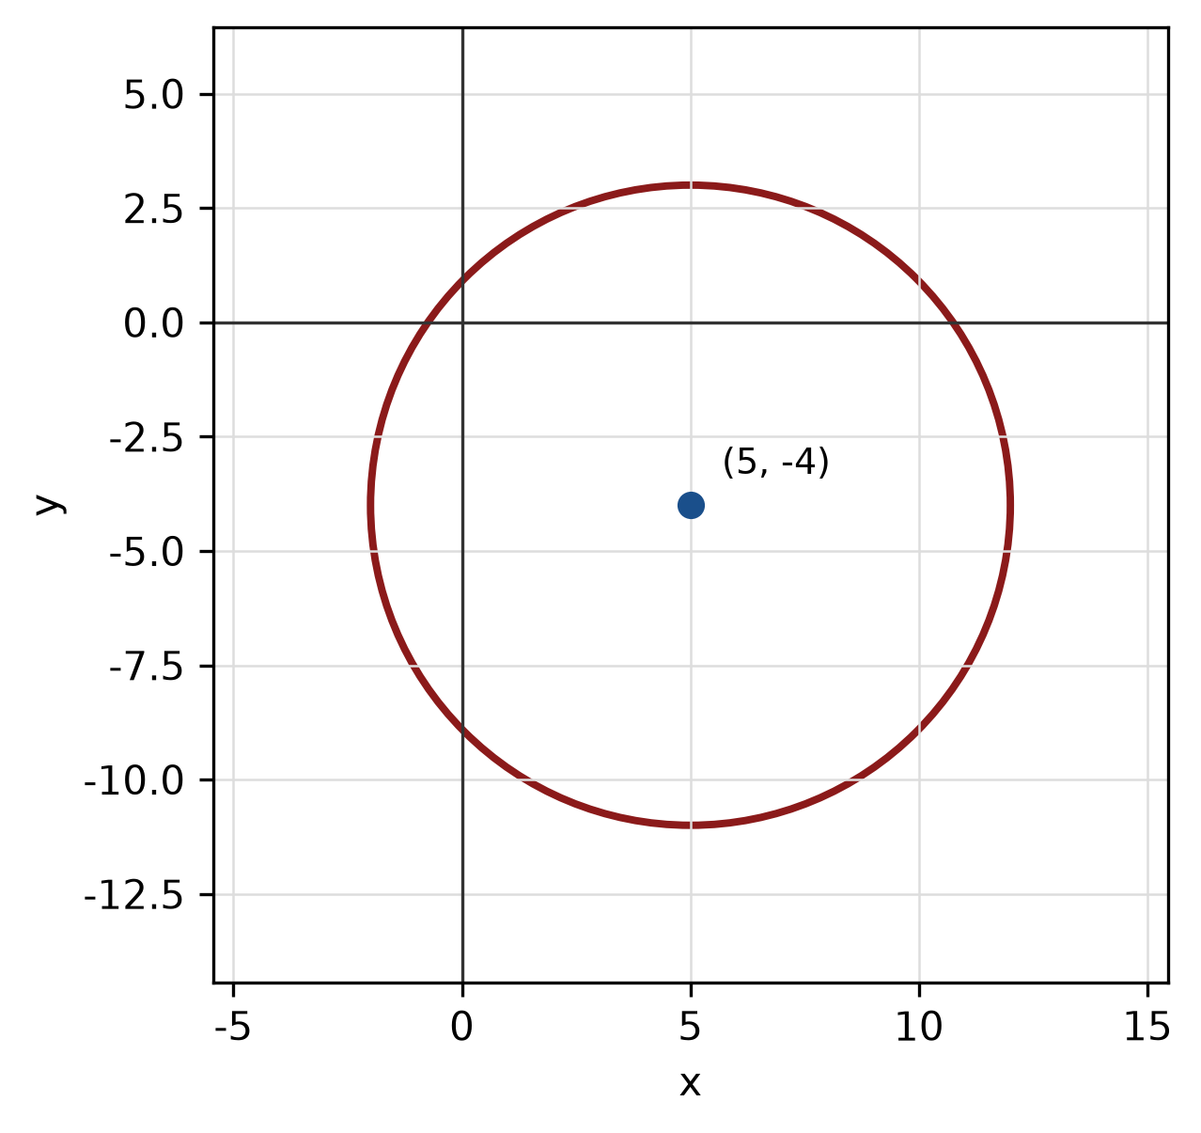
Figure: circle.
QUESTION 3
a) Given z₁ = -1 - i and z₂ = -1 - 4i, express z₁/z₂ in the form a + bi.
(5 marks)
b) Find the modulus and argument of z = -3 + 4i. Give the argument in degrees correct to one decimal place.
(5 marks)
c) Use synthetic division to divide f(x) = -2x^3 + 5x² + 5x + 4 by x + 4. State the quotient and remainder.
(5 marks)
QUESTION 4
a) Solve the simultaneous equations
-3x - 2y = -10
-x - 2y = -10.
(4 marks)
b) Write a system of inequalities that describes the shaded triangular region with vertices (0, 0), (4, 0) and (0, 4).
(5 marks)
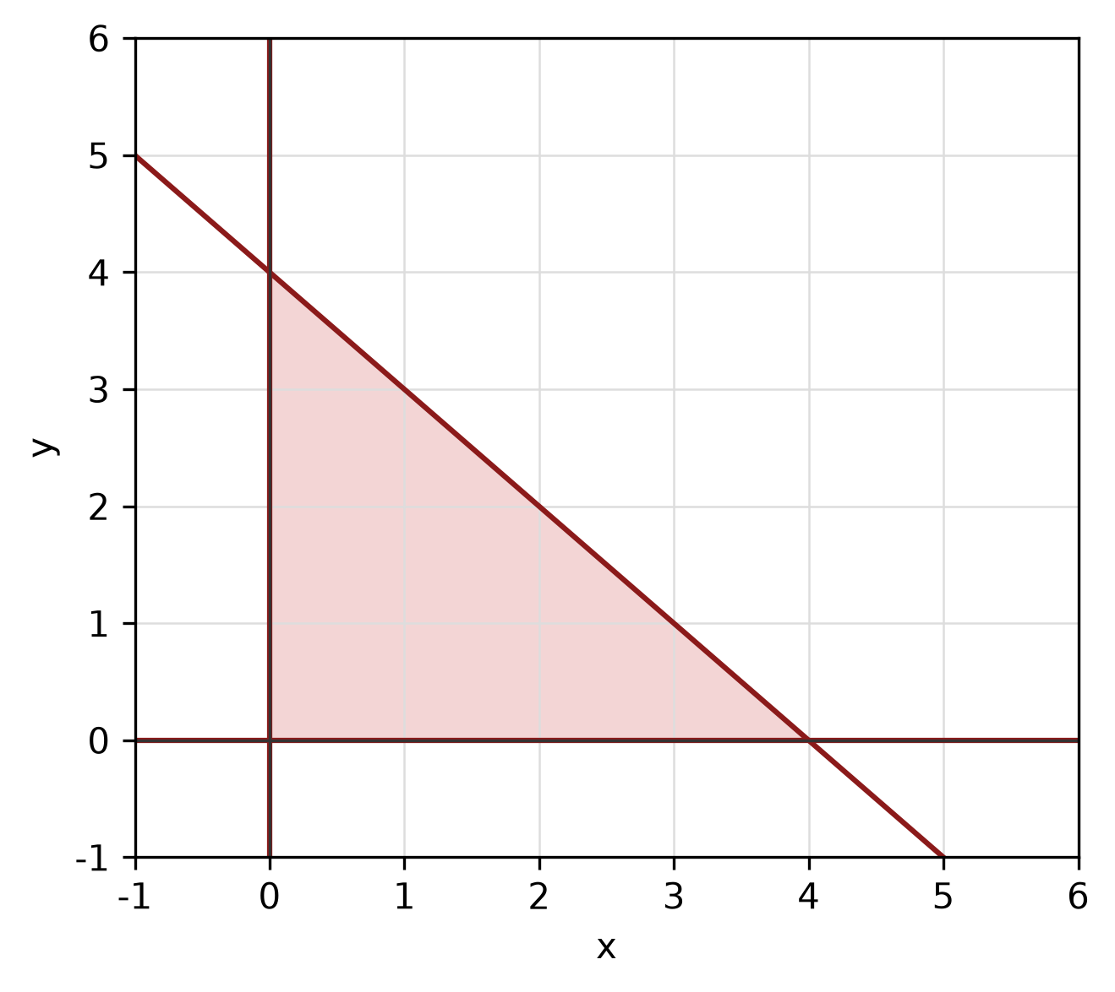
Figure: shaded triangular region.
c) Find the equation of the straight line passing through (-1, -1) and (-3, 3).
(4 marks)
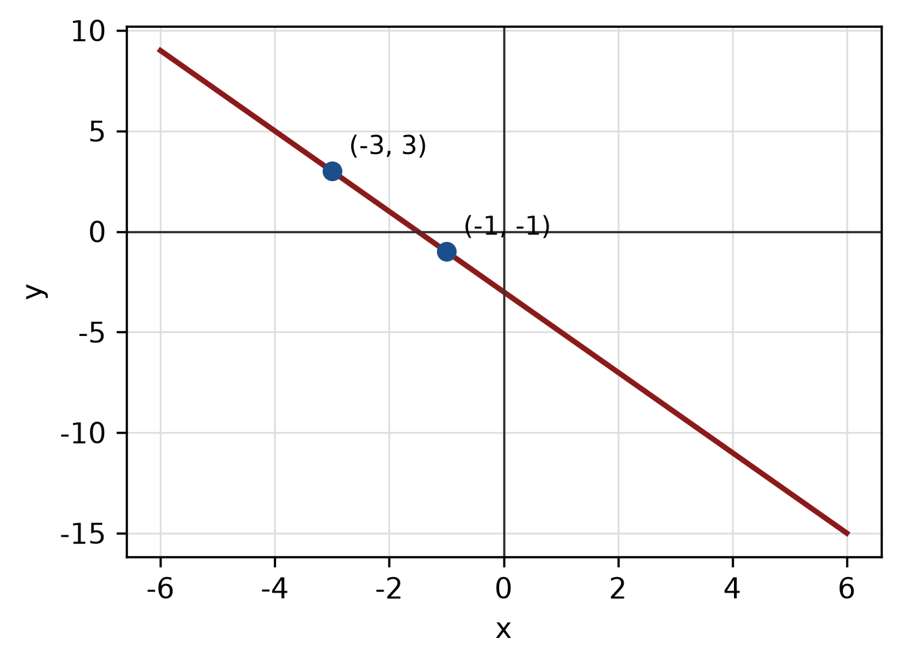
Figure: line through the two points.
QUESTION 5
a) Solve the trigonometric equation -cos x - cos(2x) - 1 = 0 for 0° ≤ x < 360°.
(5 marks)
b) Find the perimeter of the sector with radius 6 cm and central angle 45°.
(4 marks)
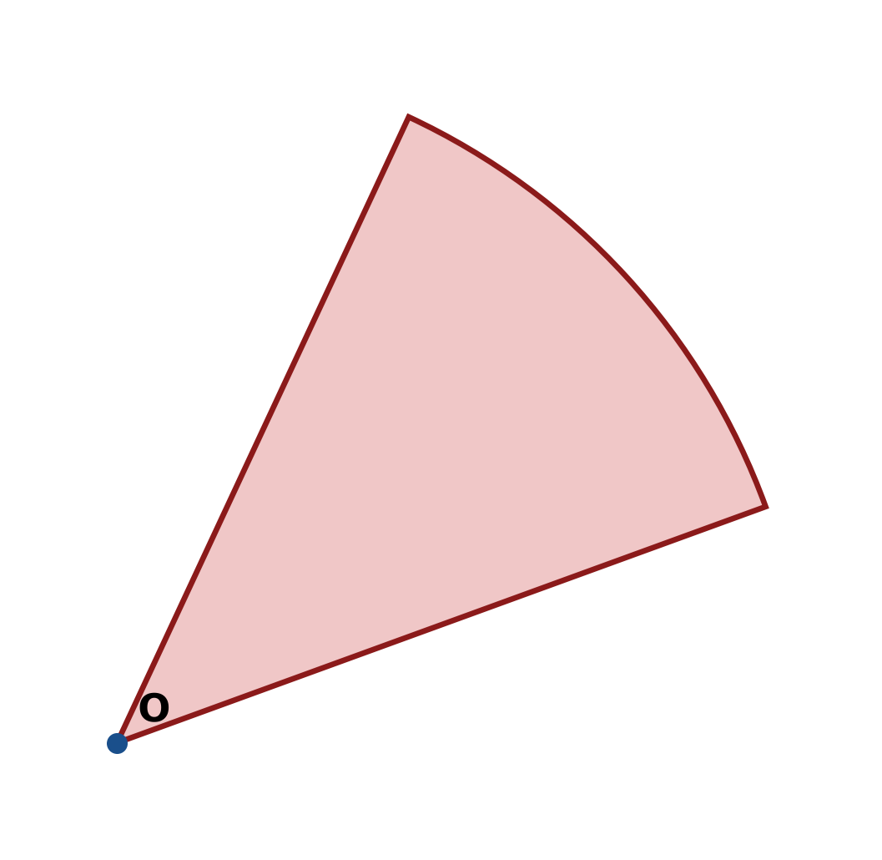
Figure: sector.
c) Solve the triangle with sides a = 15 cm, b = 36 cm and c = 39 cm. Find all three angles.
(5 marks)
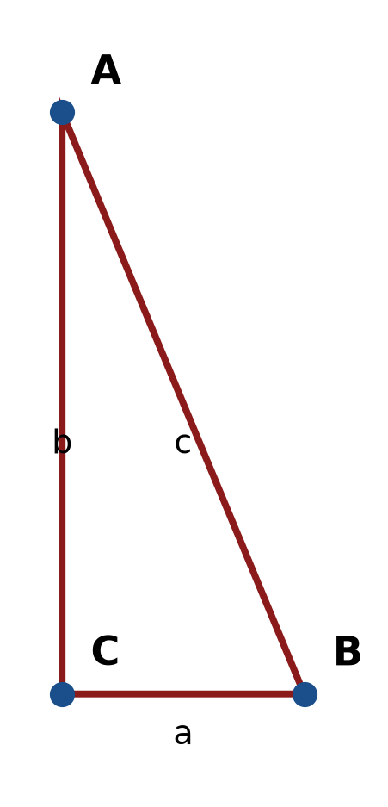
Figure: right triangle.
END OF QUESTION PAPER

APPENDIX 1
Formula sheet (as supplied with the paper).
sin² A + cos² A = 1 | tan² A + 1 = sec² A
sin(A + B) = sin A cos B + cos A sin B | tan 2A = 2 tan A / (1 − tan² A)
cos(A + B) = cos A cos B − sin A sin B | Arc length, s = rθ
tan(A − B) = (tan A − tan B) / (1 + tan A tan B) | Area of sector = ½r²θ
cos 2A = cos² A − sin² A | a / sin A = b / sin B = c / sin C
cos 2A = 1 − 2sin² A = 2cos² A − 1 | a² = b² + c² − 2bc cos A
sin 2A = 2 sin A cos A | Area of triangle = ½ab sin C

